CMOS Logic Family

Inverter
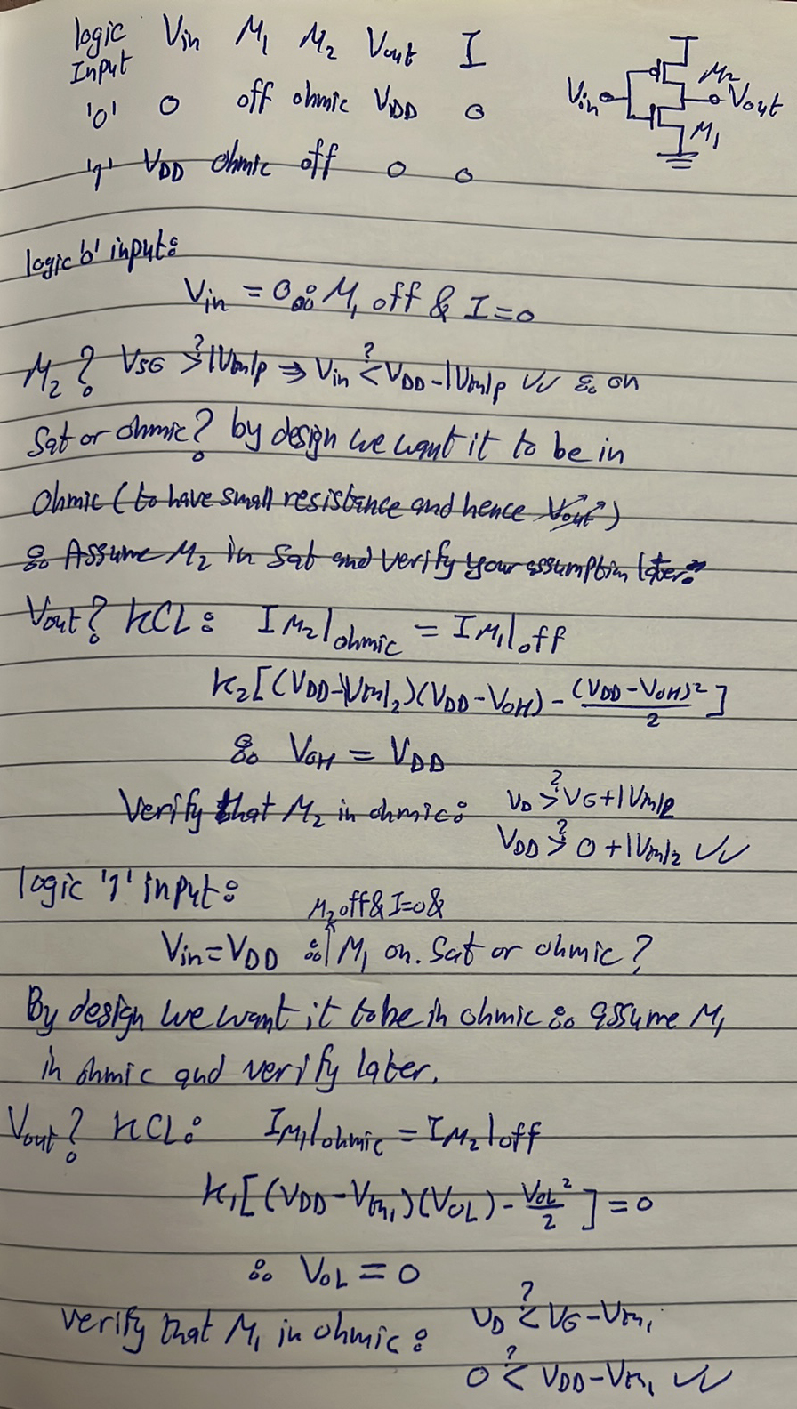

NOR Gate
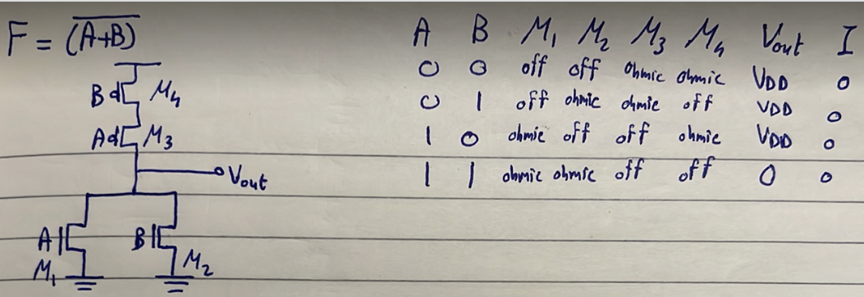

NAND Gate
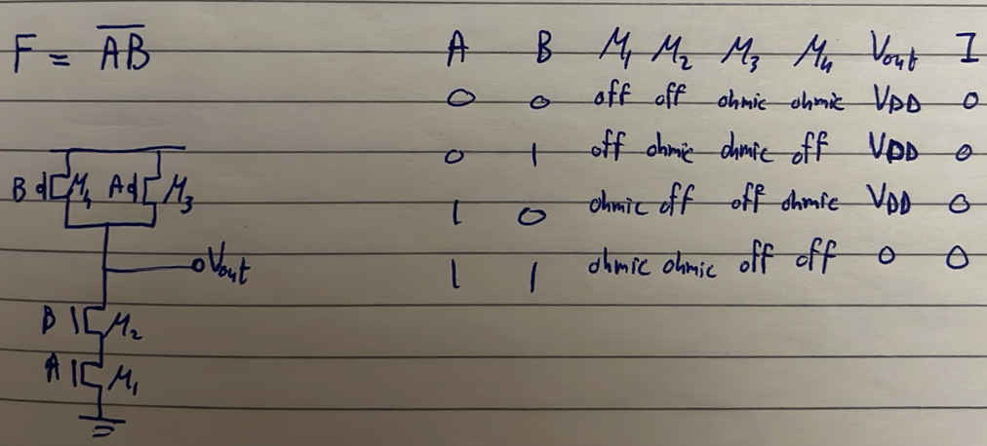

Inverter Voltage Transfer Characteristic (VTC)
Watch Video 1.
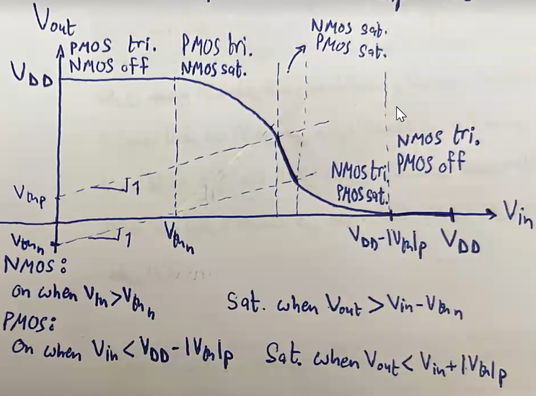

To understand any region, just write a KCL equation at the output node. However, if we tried to do so in the region in which both NMOS and PMOS are in saturation, we will get the following strange result:
$$I_{N}=I_{P}$$
$$\frac{K_{N}}{2}{\left(V_{in}-V_{th}\right)}^{2}=\frac{K_{p}}{2}{\left(V_{DD}-V_{in}-{\left|V_{th}\right|}_{p}\right)}^{2}→\boxed{1}$$
Which gives us that $V_{in}$ is constant, fema ma3nah en el sat-sat region de heya point mesh range. although e7na medeyenha range 3al rasma. Eh tafseer da?
Answer:
El bey5aly el 7eta de range mesh no2ta howa el channel length modulation effect, if we included the CLM in the previous equation we will get a logical solution:
$$\frac{K_{N}}{2}{\left(V_{in}-V_{th}\right)}^{2}(1+λ_{n}V_{DS})=\frac{K_{p}}{2}{\left(V_{DD}-V_{in}-{\left|V_{th}\right|}_{p}\right)}^{2}(1+λ_{p}V_{DS})$$

Switching Threshold ($V_{M})$
Assuming no CLM, lw delwa2ty 3ayzeen ne7seb el voltage el 3ando hayeb2a Vin = Vout ne3mel eh? Walahy Vout = Vin da howa line el slope beta3o 1 w haye2ta3 el curve beta3na 3and point haykoon 3andaha Vout = Vin bardo. Haye2ta3 el curve beta3na fel region el fiha both transistors fel saturation, w aslan assuming no CLM y3ny el sat-sat region de heya 3obara 3an point, el heya enena ne solve equation 1. Thus, the switching threshold is:
$$V_{inv.}=\frac{V_{DD}-\left|V_{TH_{p}}\right|+V_{TH_{n}}\sqrt{\frac{K_{n}}{K_{p}}}}{1+\sqrt{\frac{K_{n}}{K_{p}}}}$$
Why is this point important? because this is the "switching threshold" of the CMOS inverter! that is, heya el voltage el ablaha bene3teber el input be logic '0' w ba3daha be logic '1'.

What if we want $V_{inv.}$ to be $\frac{V_{DD}}{2}$?
- $V_{TH_{n}}=|V_{TH_{p}}|$
- $K_{n}=K_{p}$
Watch Video 2 (don’t worry, mafeesh videos na2sa wala haga).

Noise Margin
Until know, we knew that:
- $V_{OL}→$cleanest ‘0’
- $V_{OH}→$ cleanest ‘1’
We want to define two more quantities:
- $V_{IL}→$ logic ‘0’ input at which the slope is -1, and we consider it the worst logic ‘0’; the maximum value that the inverter can interpret as a logic ‘0’.
- $V_{IH}→$ logic ‘1’ input at which the slope is -1, and we consider it the worst logic ‘1’; the minimum value that the inverter can interpret as a logic ‘1’.

For example, for the CMOS family:
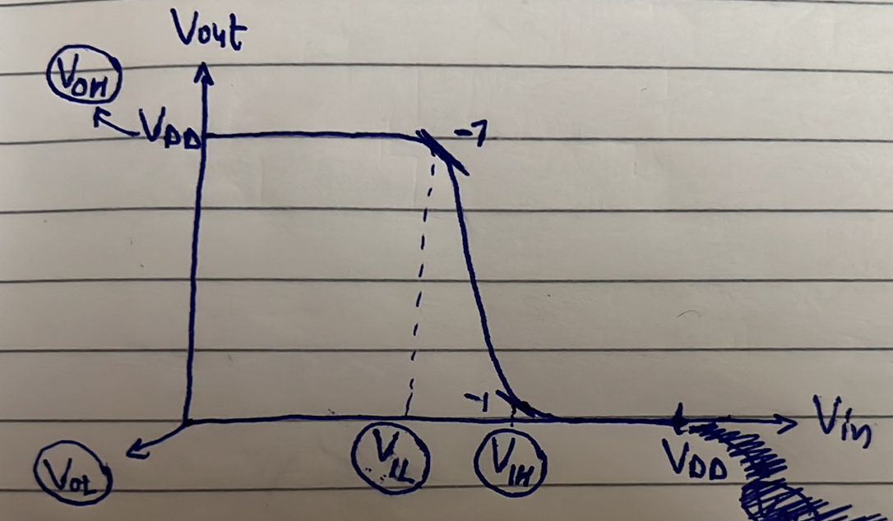
Watch video 3.

Noise margins are given by:
$$NM_{H}=V_{OH}-V_{IH}$$
$$NM_{L}=V_{IL}-V_{OL}$$
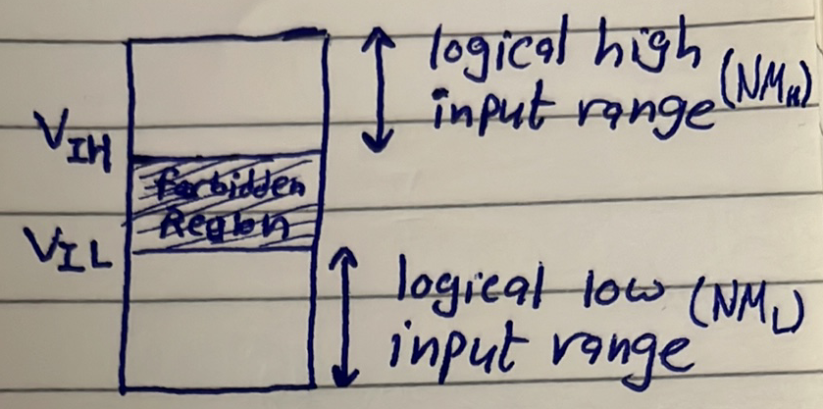
So why should we avoid the high gain region?
Because it is too sensitive to noise.
How to calculate $V_{IL}$ and $V_{IH}$?
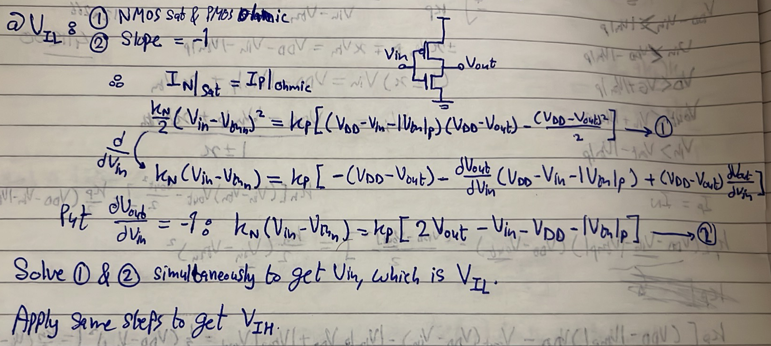
Always remember: KCL at the output node!
Back to the enhancement-load inverter:
Now 3ayzeen ne3eed kol el steps de tany ma3 el enhancement load inverter 3ashan ne compare it ma3 el CMOS w nshoof leeh el nas e5taret el CMOS. Watch this from 48:33 to 58:33.
Yeb2a 5aly balak eh el ma3loma el asaseya el ba3rafha men el VTC? Noise Margins.

